

|  |
| --- |
| Apparel and Footwear |
| **Cost Wizard** |
| Argentis Consulting |



**www.argentisconsulting.com**

Cost Wizard

The following is the step by step process to perform the allocation of manufacturing overhead costs to the Cost of Products in Stock.

This process is run at the beginning of each month to have information of the previous month.

Go to Production 🡪 Cost Wizard

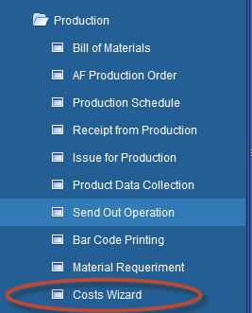

* Select the Cost Adjustment Period

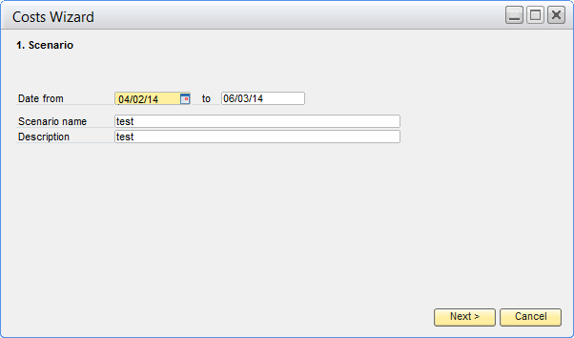

* Select the Indirect Cost Accounts

Select the Accounts containing costs that you need to send to the cost of the Finish Items. It search the Debit Balance of that account.

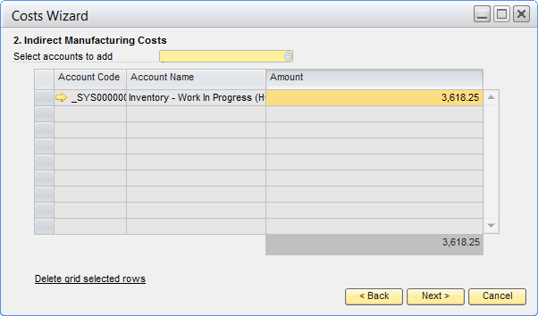

* Select the Total Labor Cost

Select the Labor Accounts containing Labor Costs. It search the Debit Balance of that account.

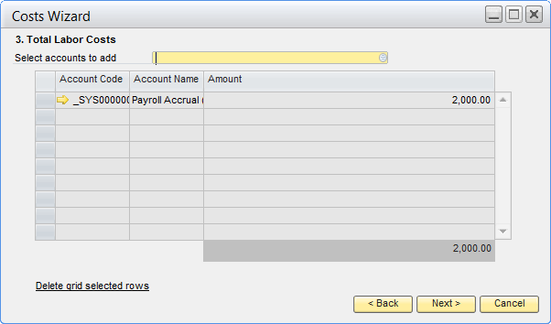

* Select Total Manufacturing Labor cost

The Wizard should indicate the code of Accounting Account associated with production operations that were associated with the structure of the Item. Client reports associating Operations production cost centers through the WorkCentre. Search the Debit Balance of that account.

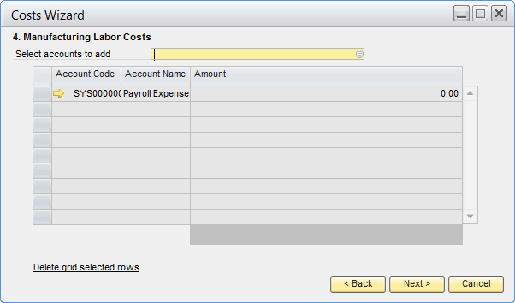

Review Un-productive Capacity

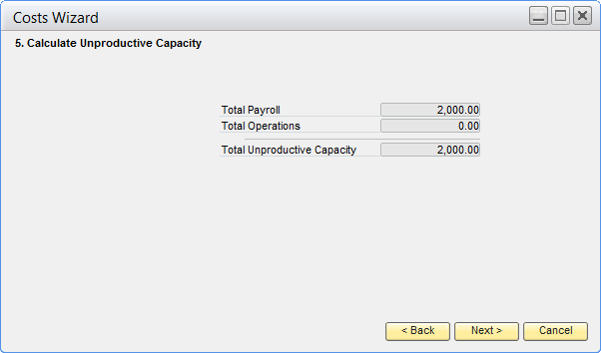

Review Total Cost Revaluation

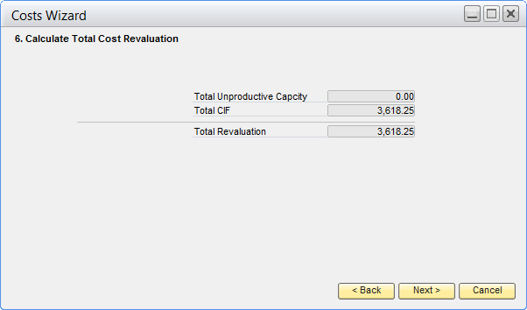

Select accounts for Jornal Entry

#### 

Determintation Cost Revaluation according the Operation Cost of each of the item

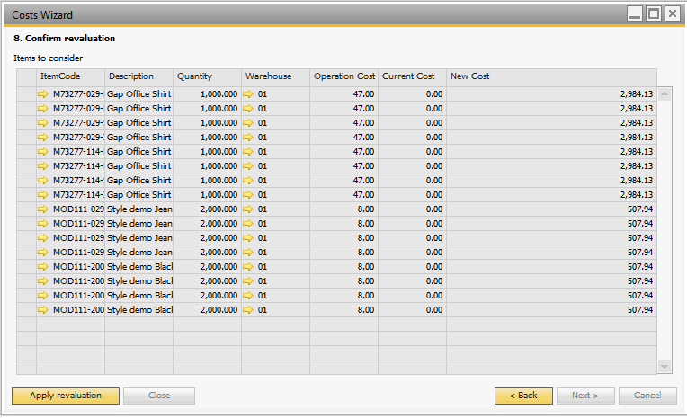

Operation Cost of each of the item in the BOM

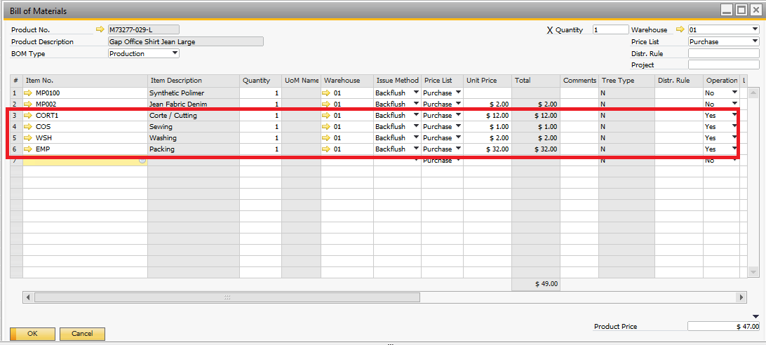

Confirm Revaluation and Jornal Entry

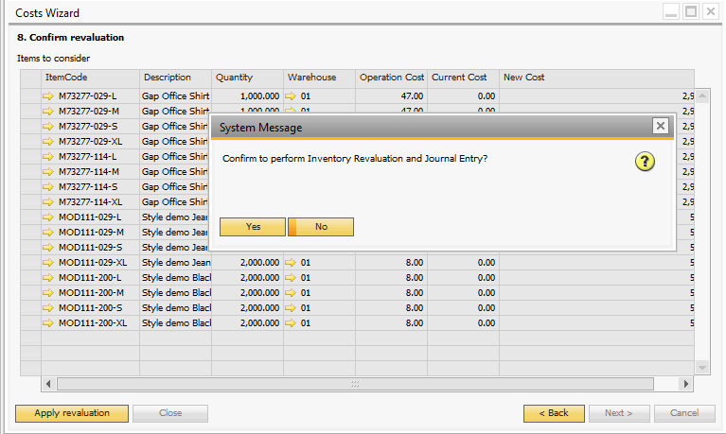



**Argentis Consulting** is dedicated to the development, distribution and support of recognized certified solutions for SAP Business One, as an SSP (Software Solution Provider) with a Gold Partner status.

**www.argentisconsulting.com**

|  |  |
| --- | --- |
| **USA**  9744 NW 45th Lane  Doral, FL 33178  info@argentisconsulting.com | **ARGENTINA**  Ávila y Zarate 2048  Cerro de la Rosas, Córdoba,  CP 5009  Córdoba - Argentina  info@argentisconsulting.com |
| **CARIBEAN**  City View Plaza – Suite 301  48 Road 165  Guaynabo, PR. 00968  Puerto Rico  caribe@argentisconsulting.com | **SPAIN**  C/ Juan Bravo N° 3 A 28006  Phone: (+34) 91 123 7263  Madrid - Spain  info@argentisconsulting.com |

**Contact Information**